Things to remember:

- Never ride in an airplane named after a guy named Lloyd.
- Never book with an airline whose acronym resembles a dog or an experiment (Lloyd Aerolineas Bolivianas).
  - Although I did find the last airport in the world that allows smoking everywhere.
- Never ride next to a Cuban that says he’s a doctor (He only wanted to play doctor.)
  - Although I did meet two Cubans that were anxious to get back home. (How bad can Bolivia be?)

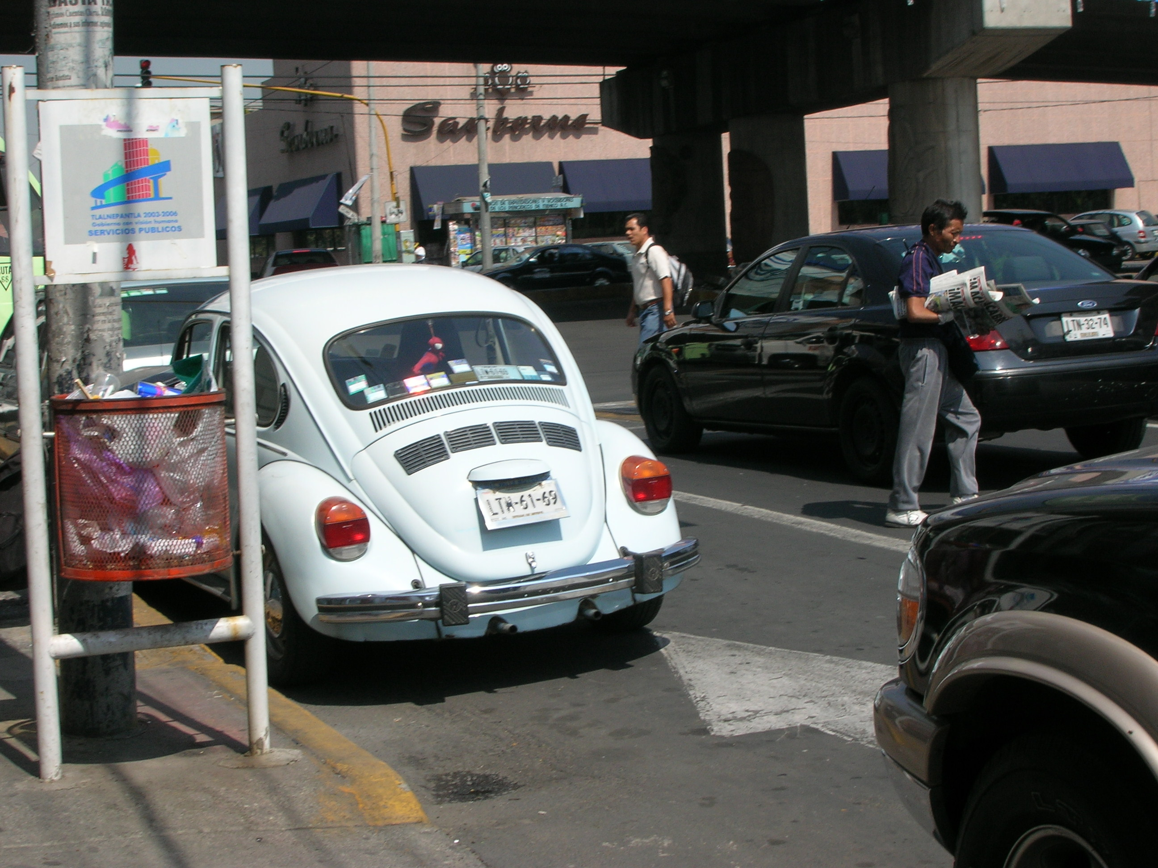
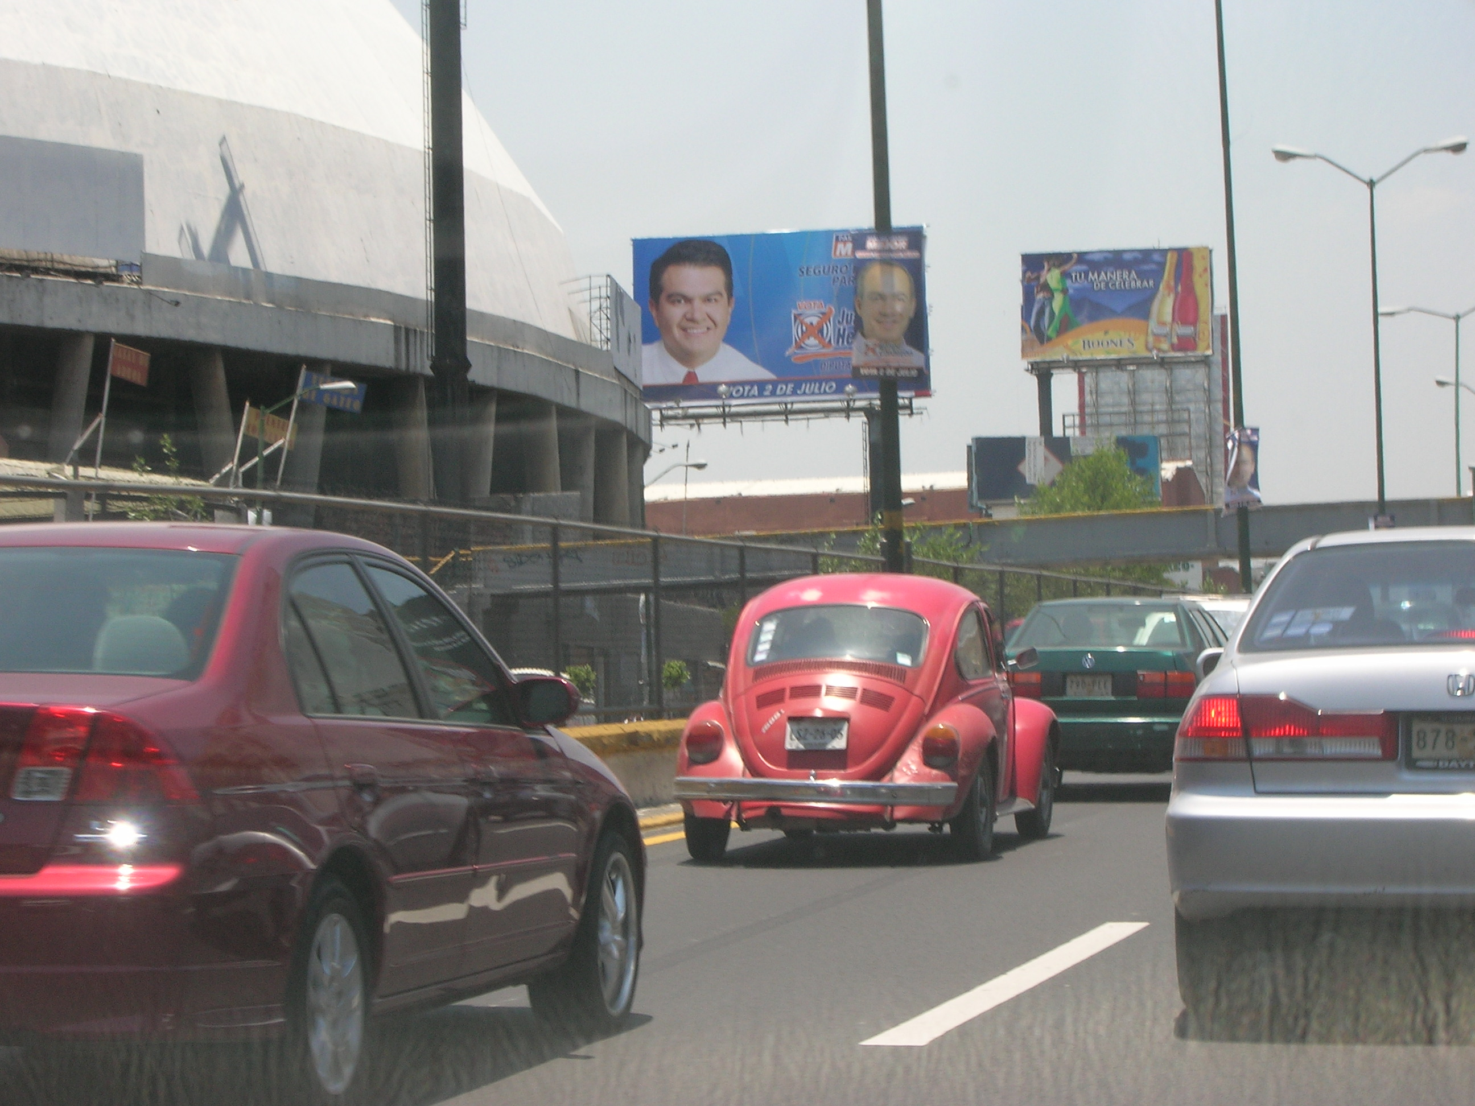
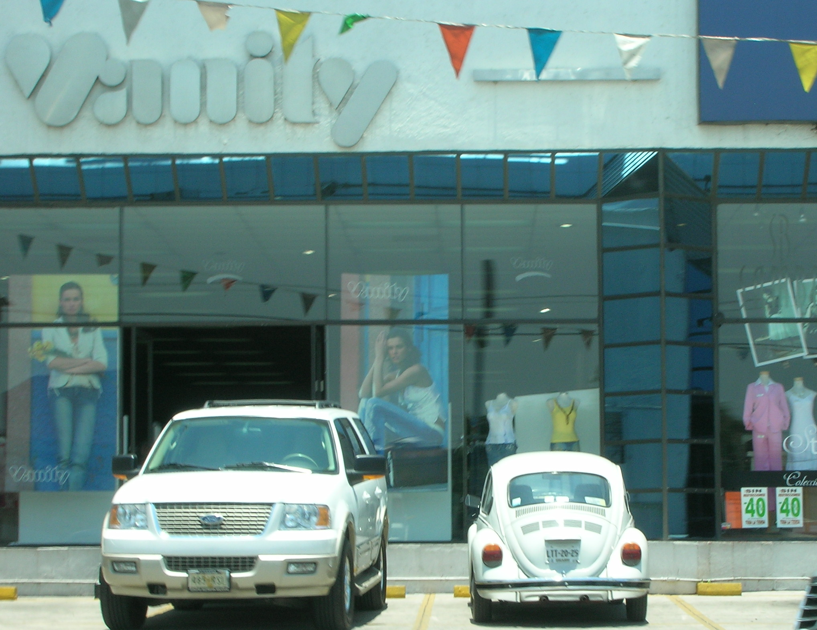
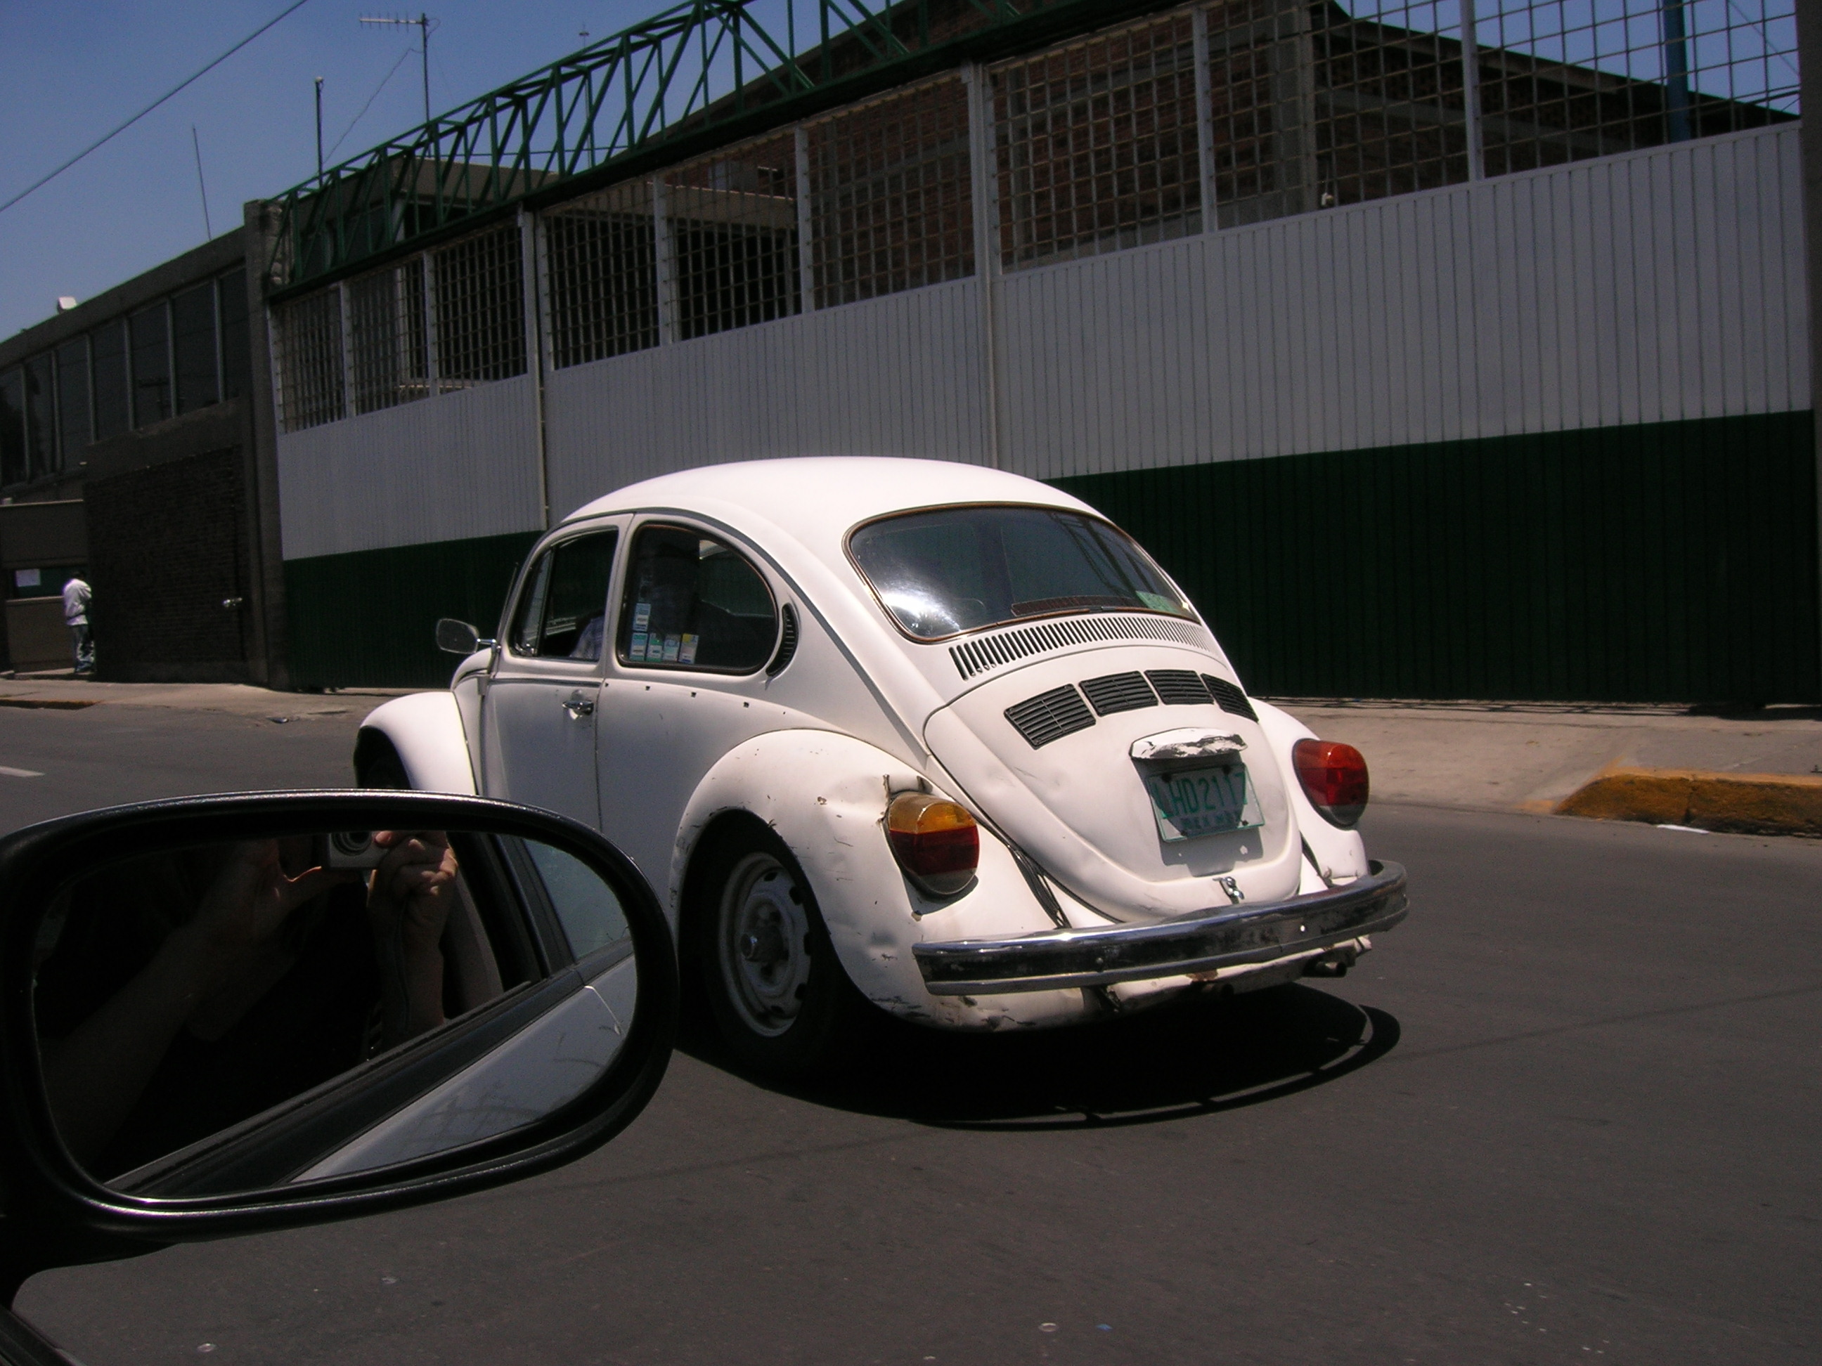
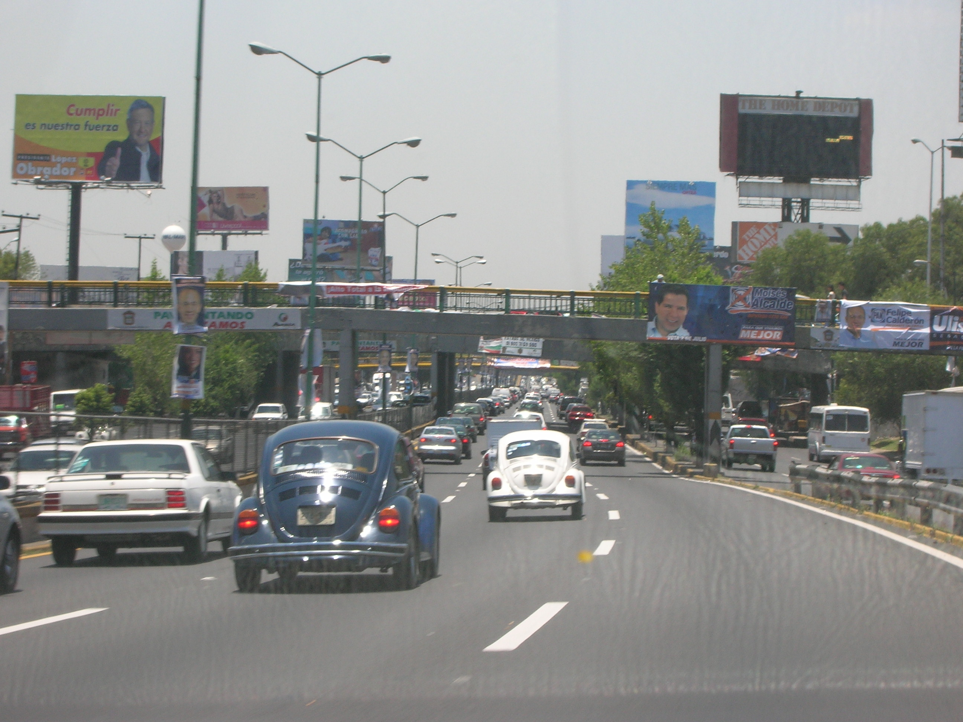
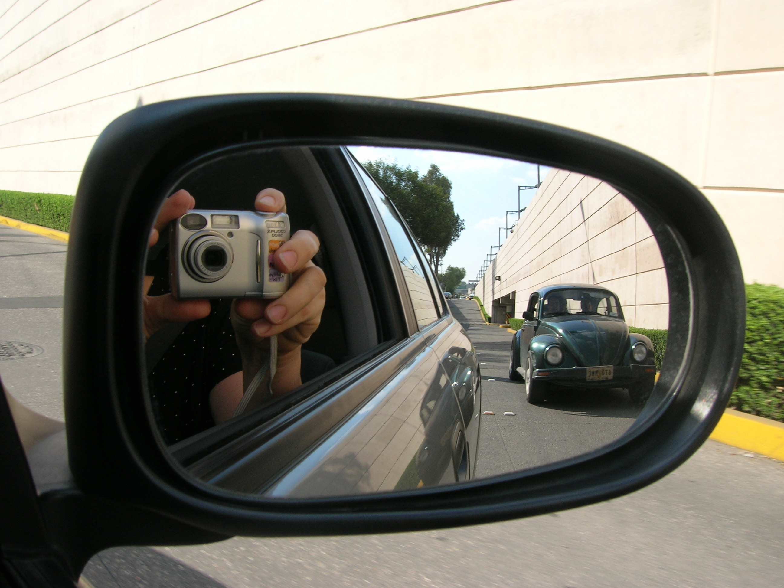
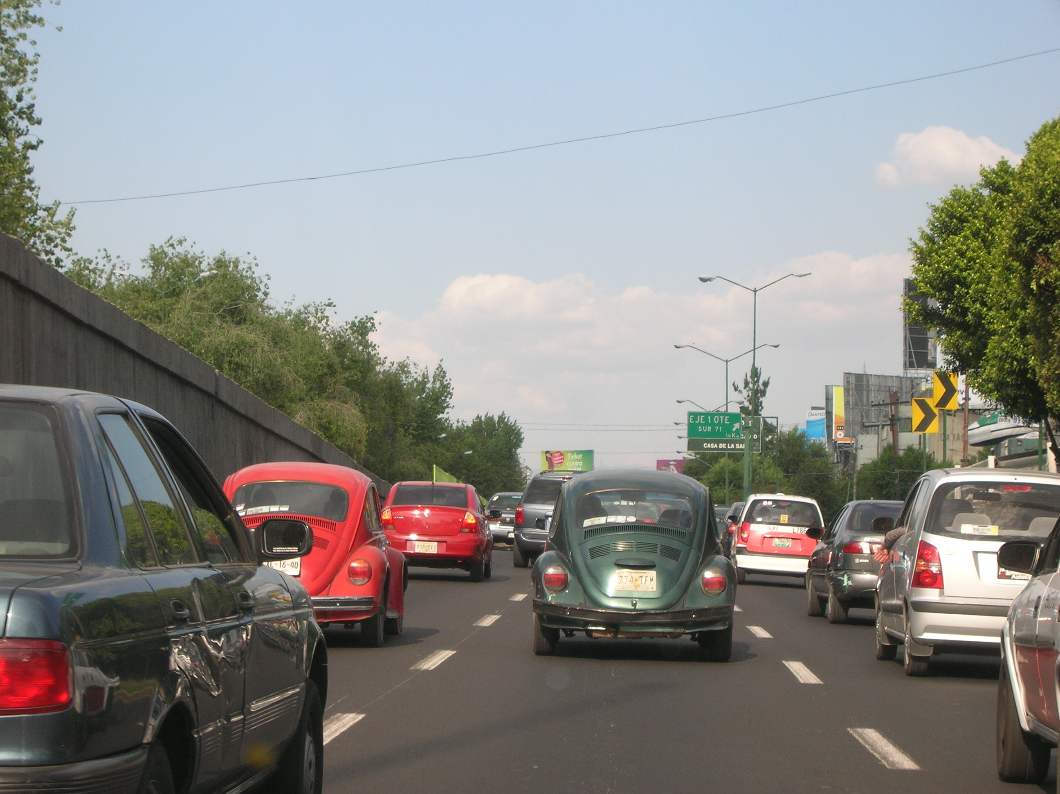
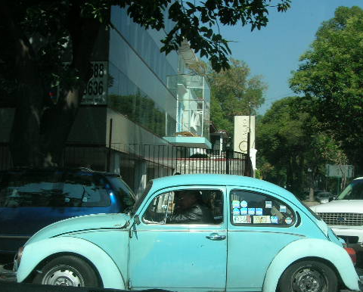
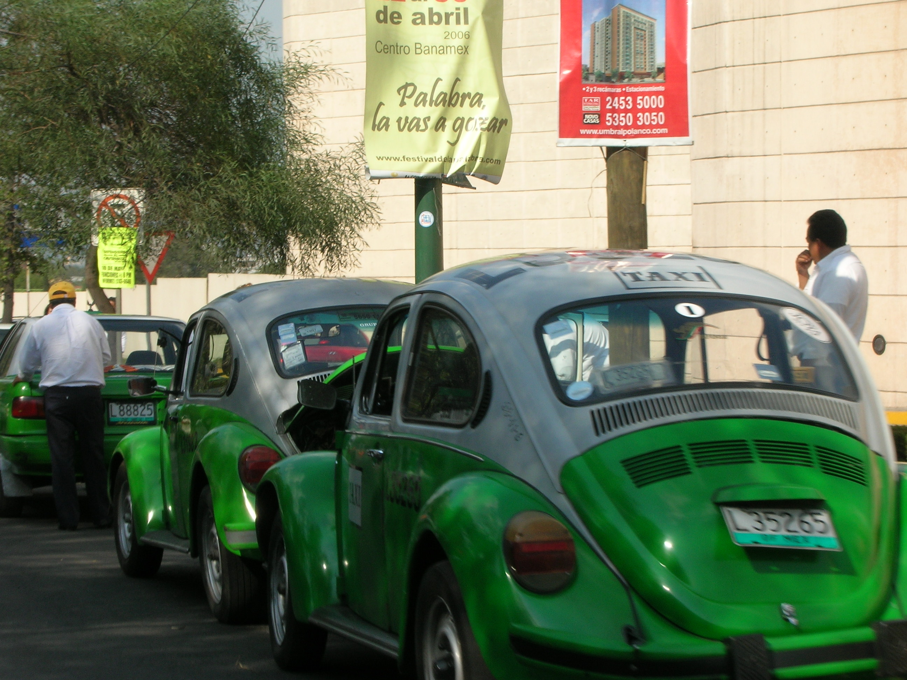
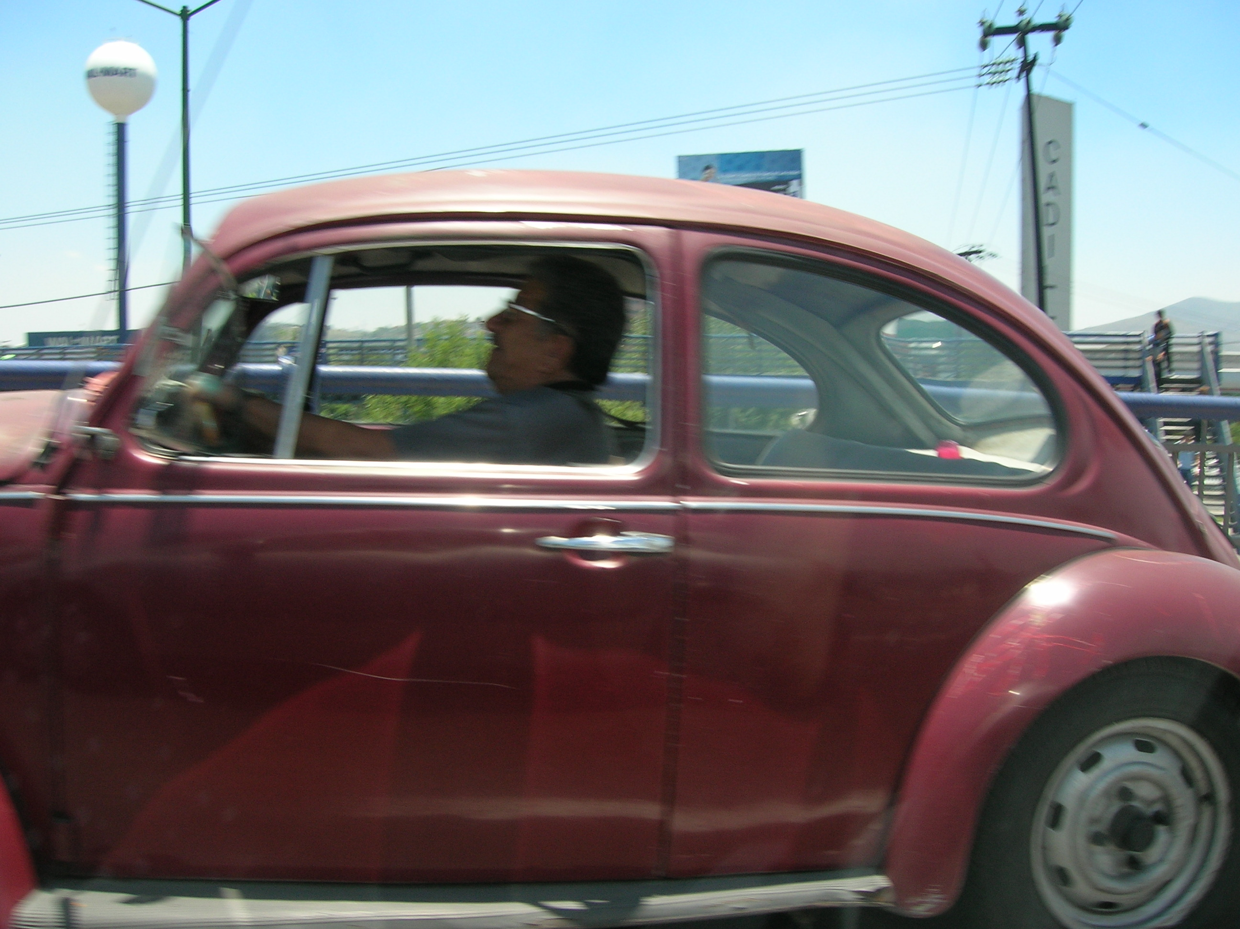
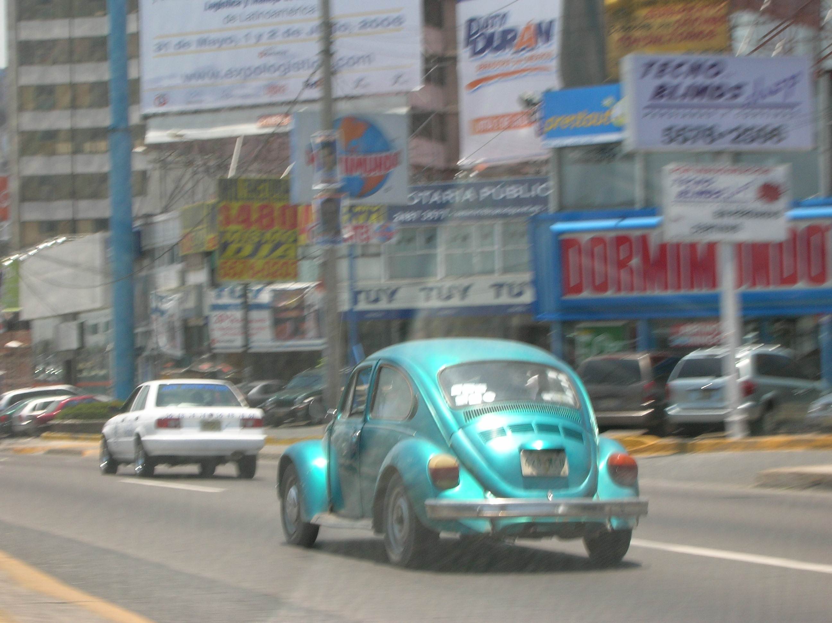
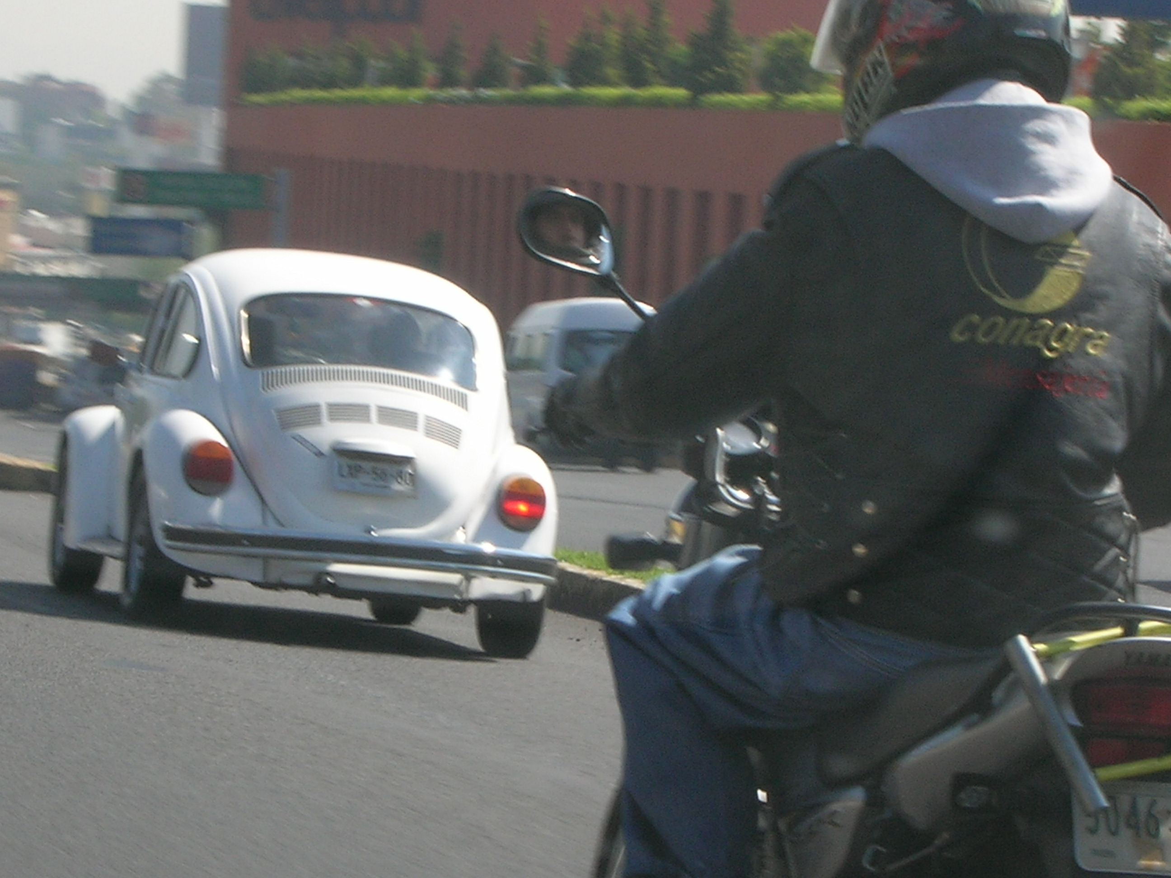

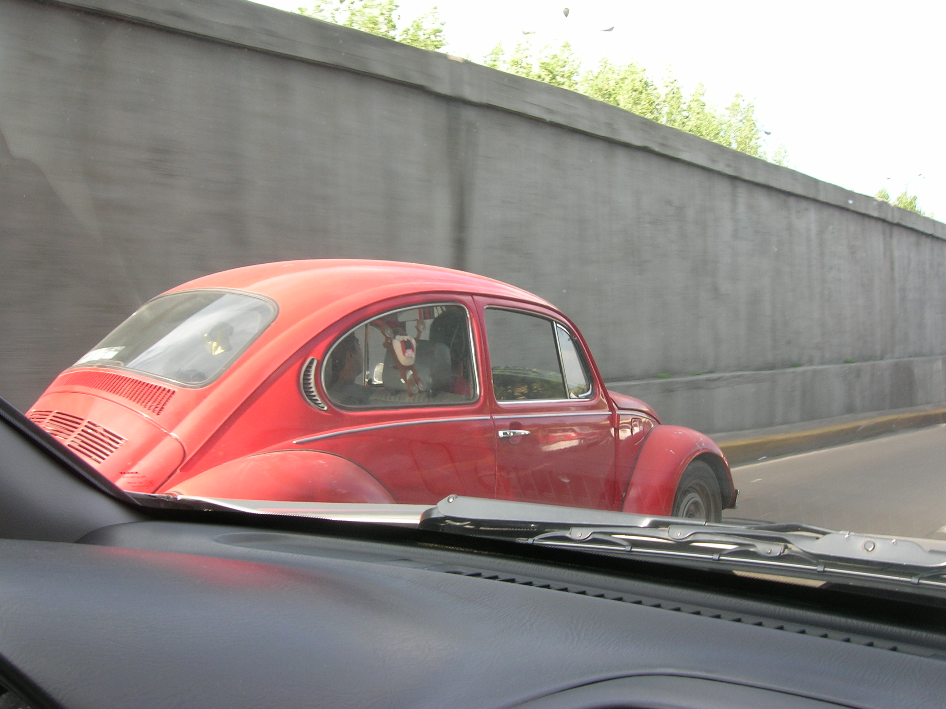
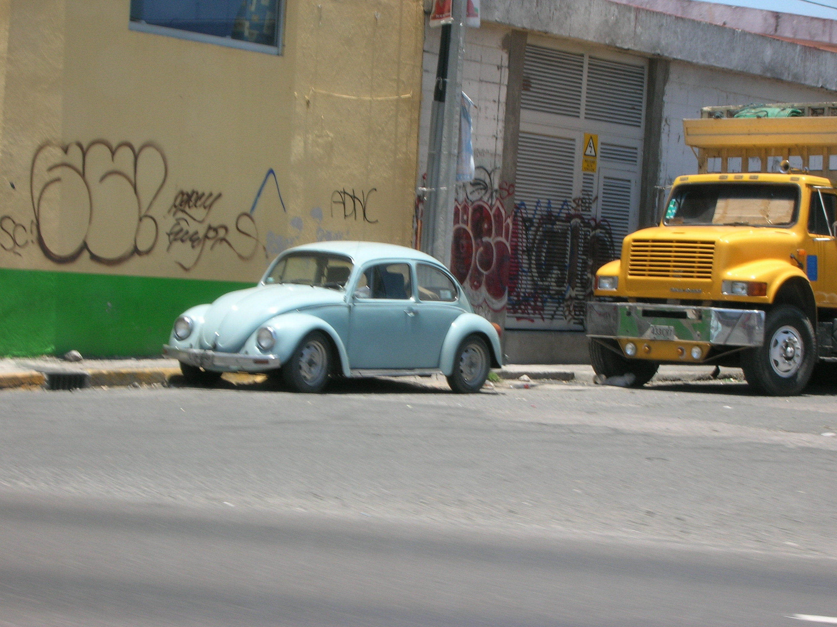
- Never play “Slug Bug” in Mexico City

- Panama has the most colorful buses | - 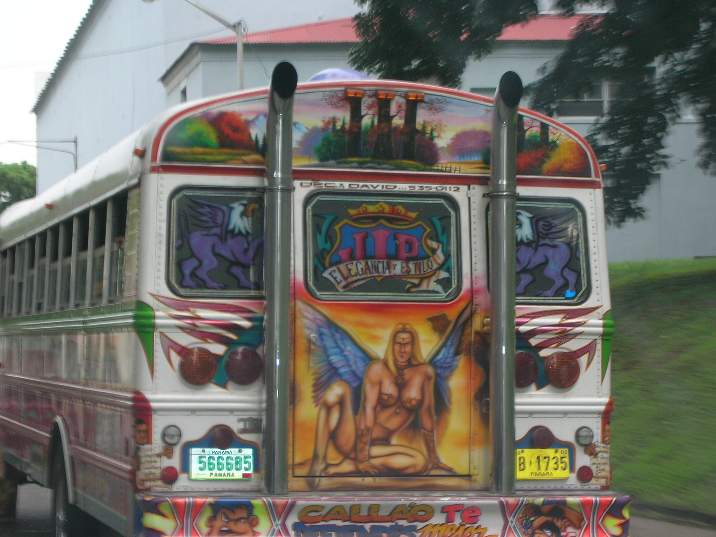
- Panama has beachfront favelas (slums) | - 

I’m about to land in Denver. U.S. Territory … just hope I make it through customs OK!

