This is definitely the worst hotel I have ever stayed in – and no, it was not in Latin America. This hotel can be found in your friendly back-yard town of Lincoln NE.
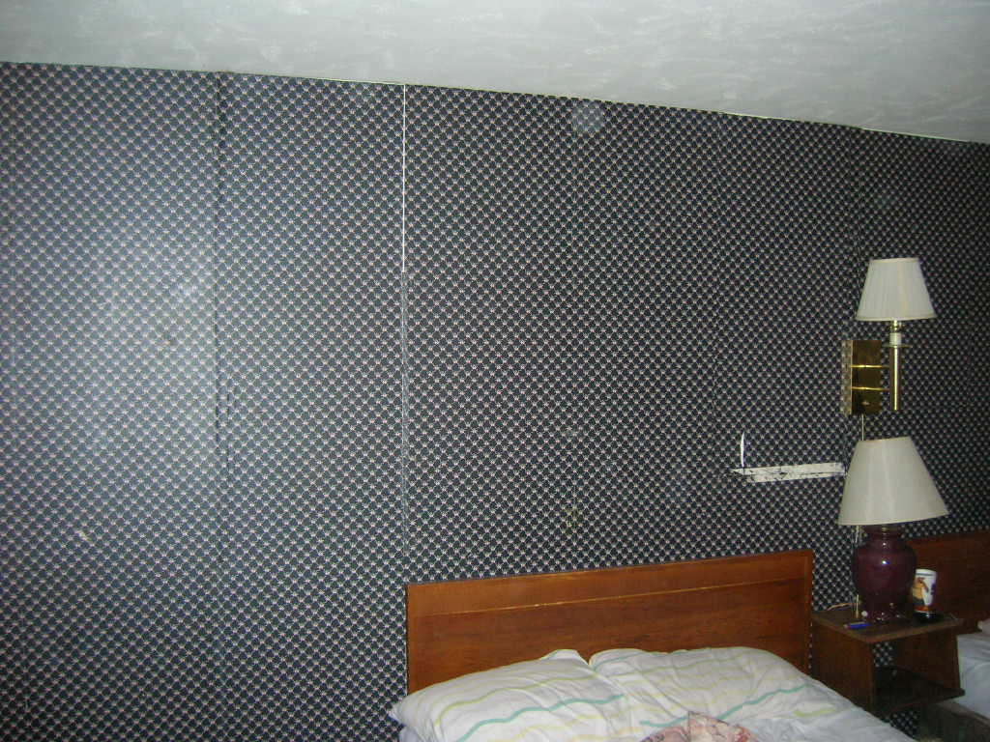

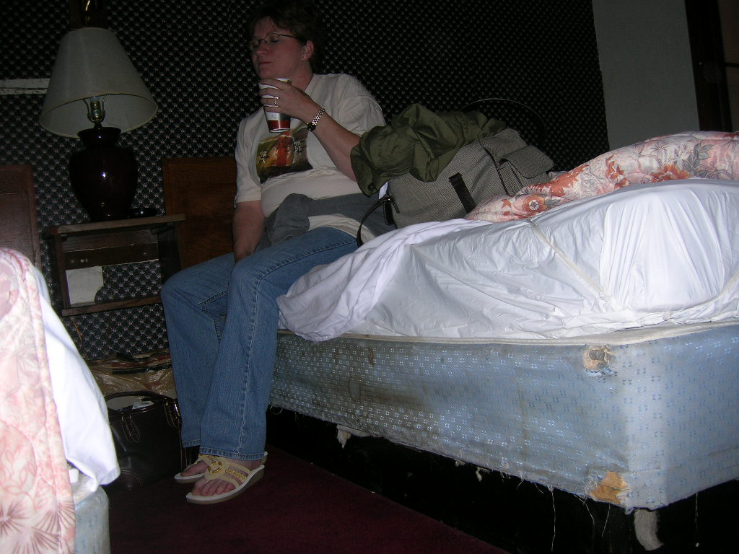
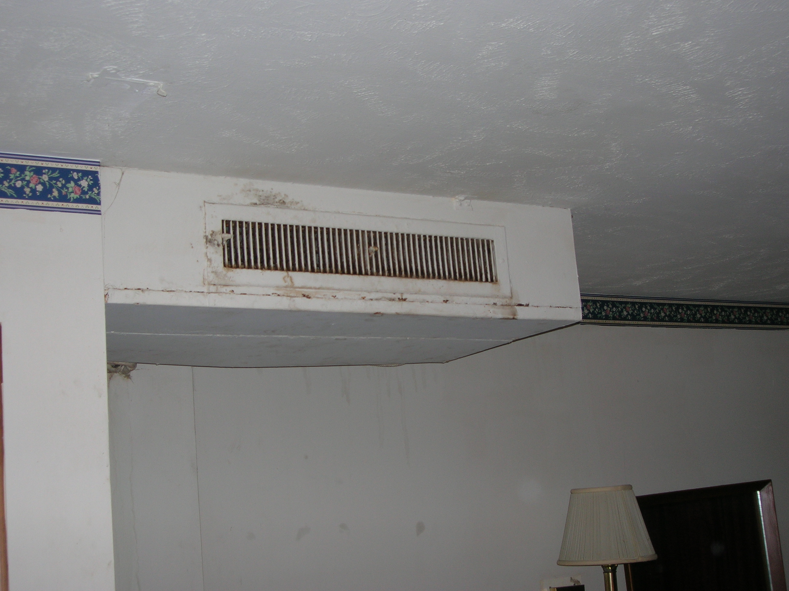
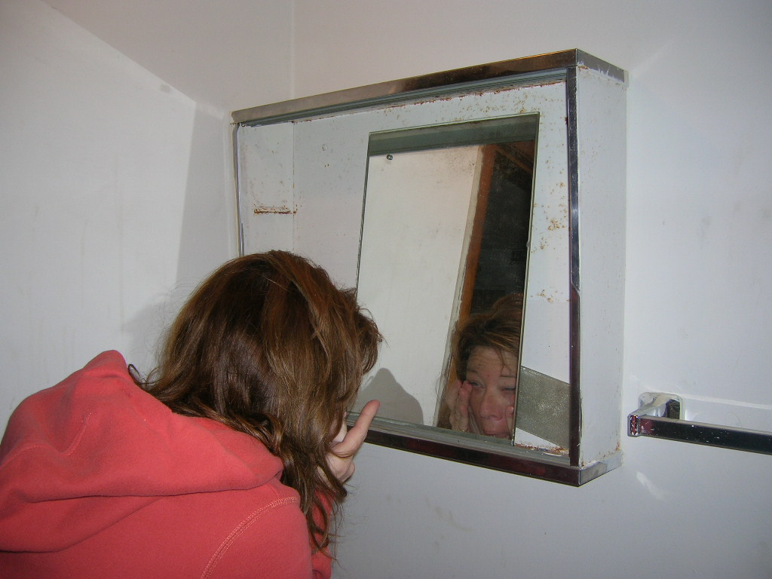

Yes, I promise to make reservations ahead of time, next time!

