Madrid Spain:
This has turned into a food blog.
I’m getting fluffy… so, I stopped down at the concierge of the Melia (5 star hotel) to find out if there is a work out facility. Not in the hotel…and the one down the street doesn’t open till 8:30 am. Apparently no one gets physical until the afternoon. At least I tried. I brought a girdle.
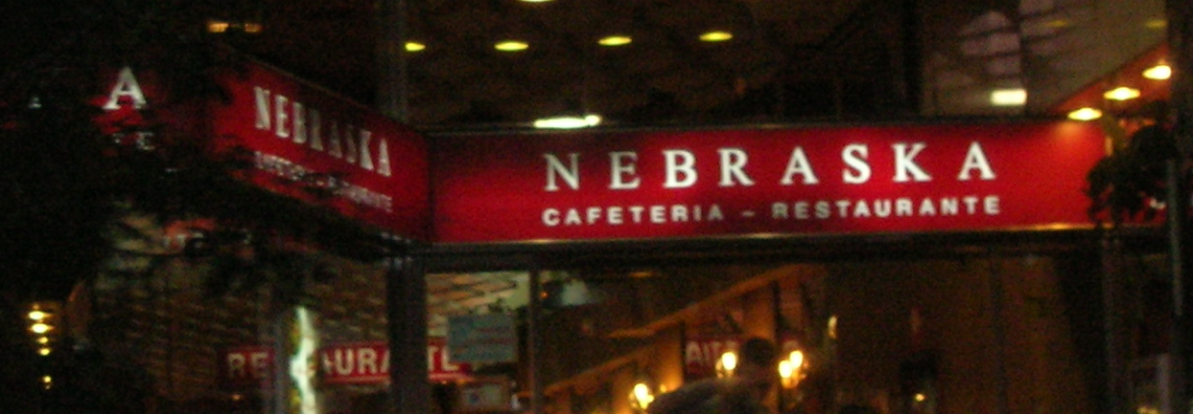
A Chain of Famous Spanish Restaurants – Go Big Red!

First night’s meal: in-room movie (Loony Tunes Back in Action – good movie), a bottle of Luis Canas Crianza Rioja, a big chuck of Manchego cheese and olives. The diet begins…

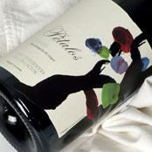
Second night dinner: black truffles (over-rated) with soup, fish and wine (oooh .. if you can find it – new wine from Spain: the grape – Mencia. Brand Petalos, (smooth – excellent –like water!) with two business associates that make more money in a day than I do all year. Always amazes me that I can carry on a conversation. Javier has had two Bushes at his house for dinner, along with various European royalty.
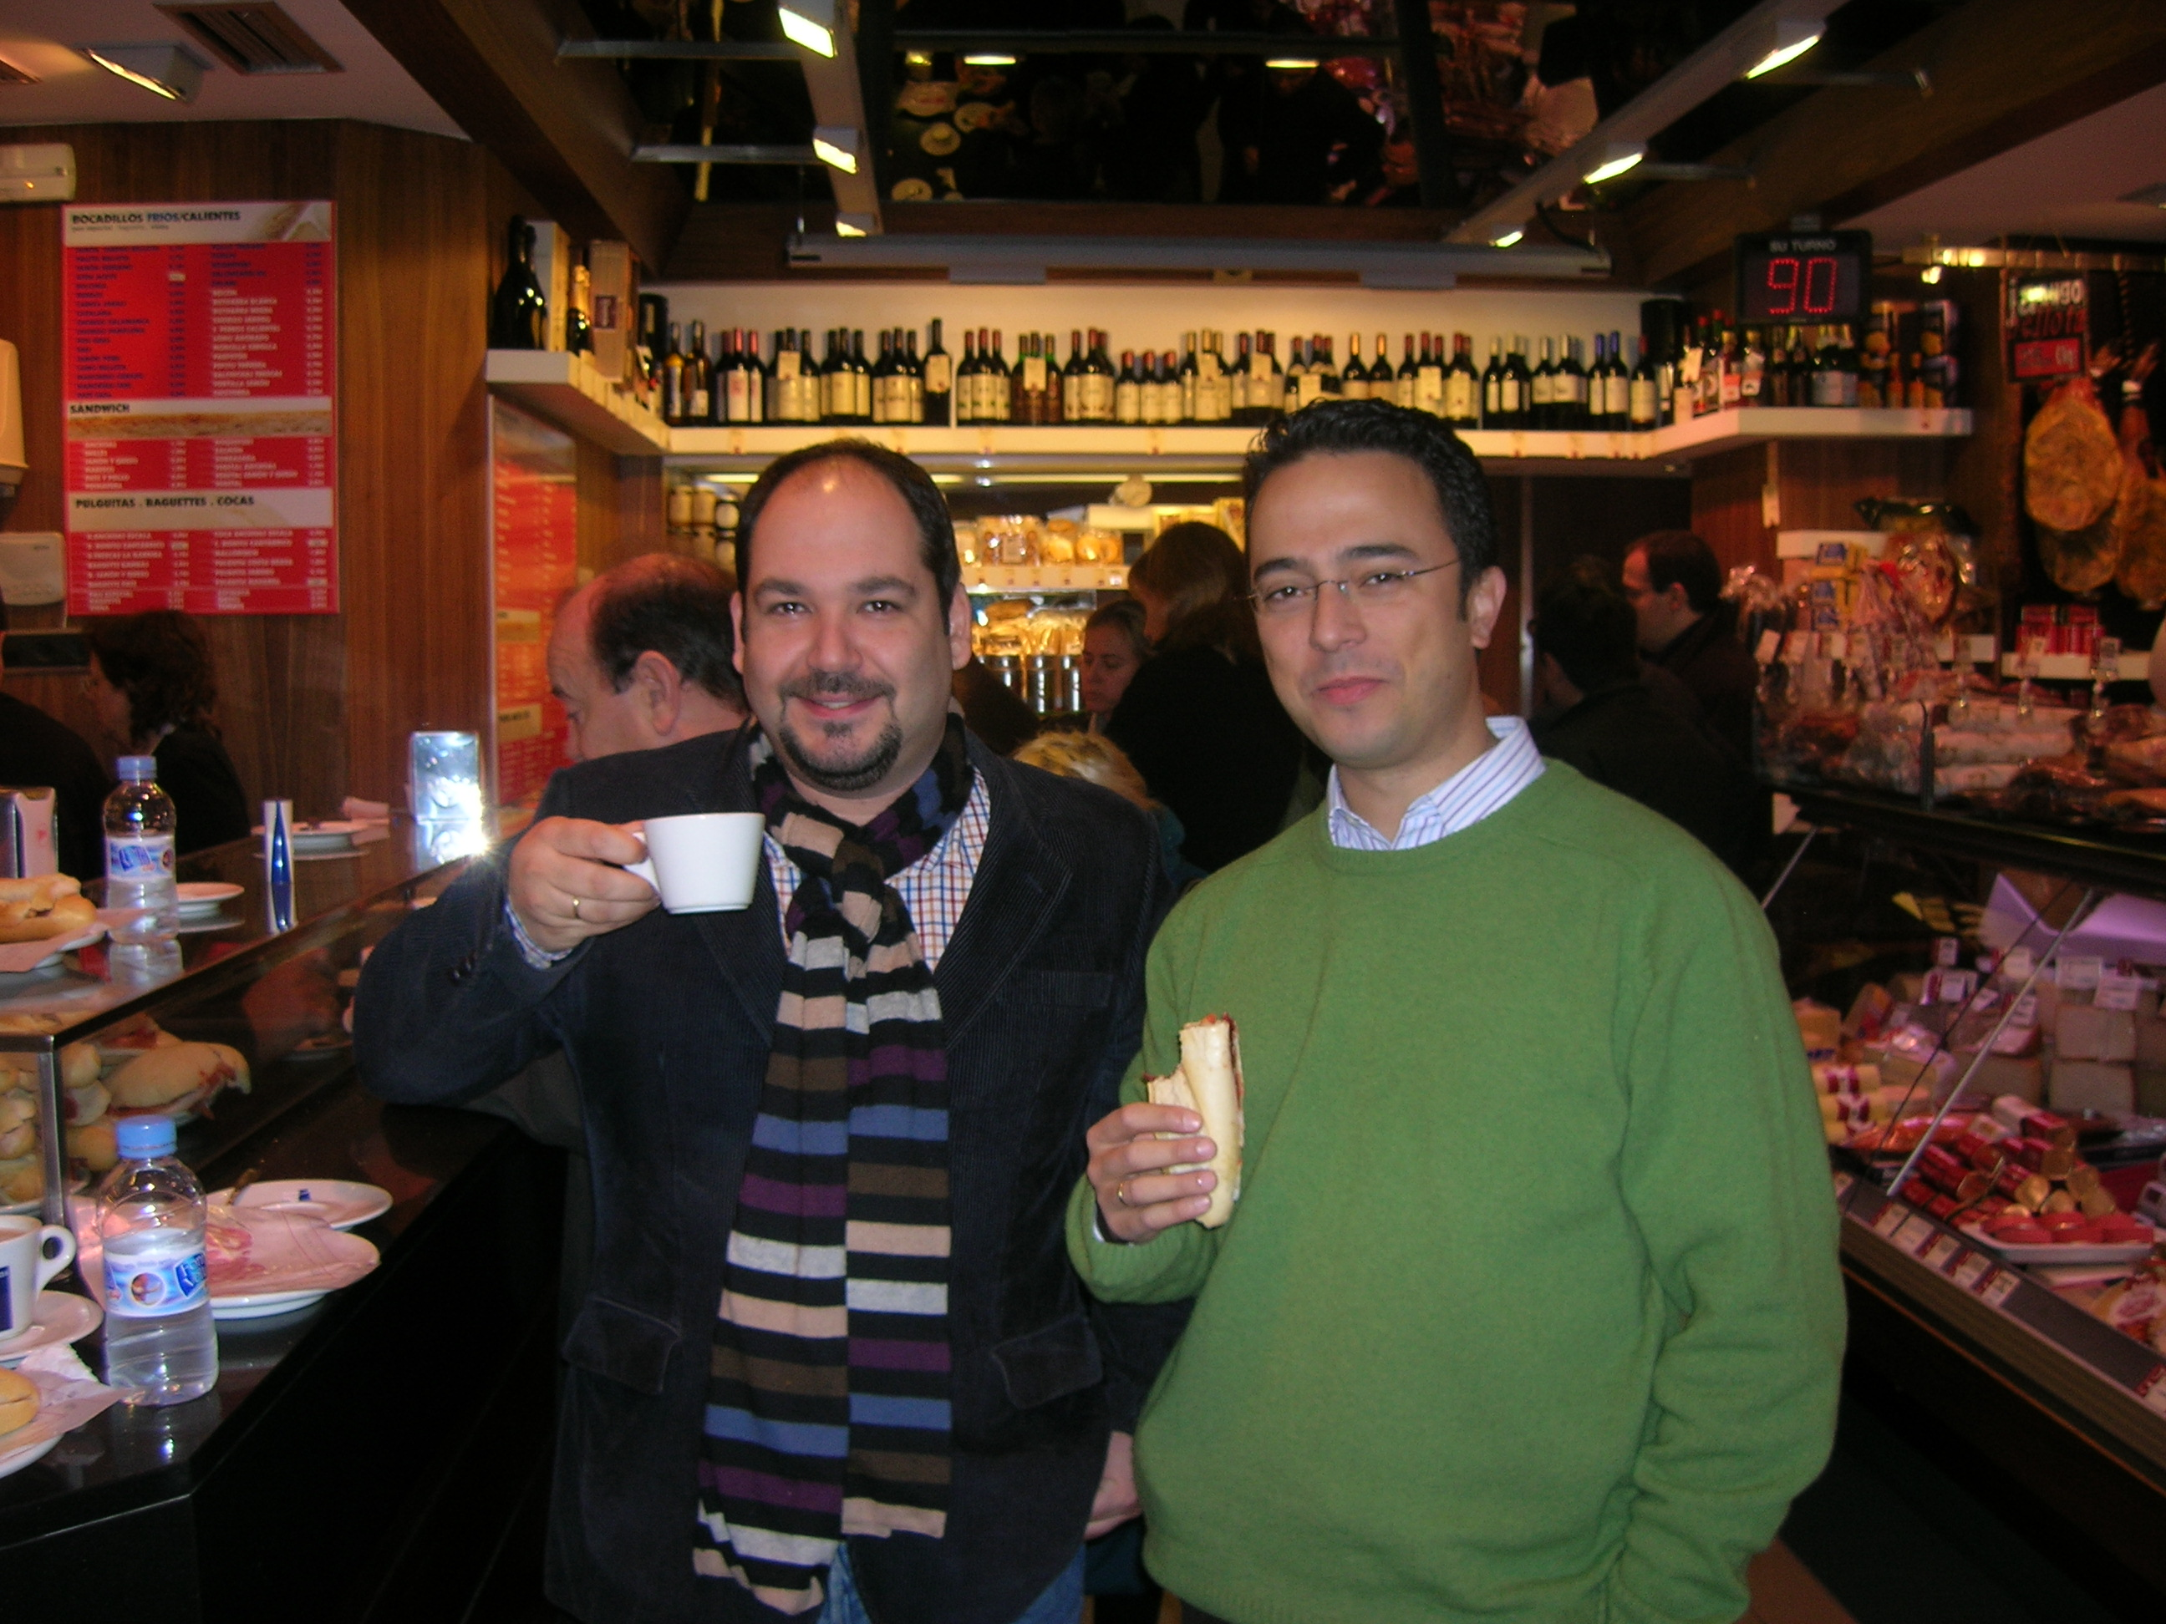
New drink – Gin and Tonic with a cucumber.

Breakfast with my co-workers. Coffee and sandwiches with ham (bocadillos). Stand up only. Guy next to us had a beer with his breakfast.

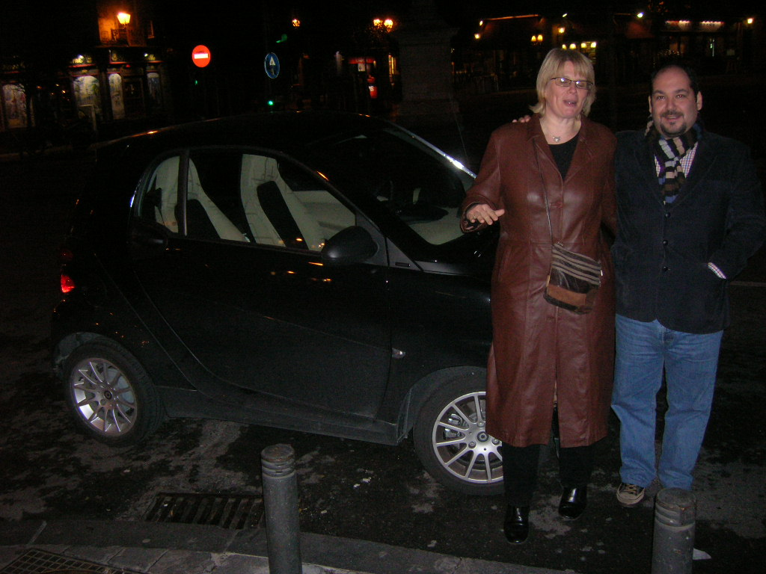
Check out the size of this car. A two-seater Mercedes. The length of the care is the same as the width of a normal car. You can park two in the same space as one, if you park perpendicular to the curb … which they do.

Went to Flamenco Tablero. You can listen to the experience at:
http://www.youtube.com/view_play_list?p=580ED6F56ACCDC81

