Chp 6 Beyond the book report: Visual Assessments of Learning
21st Century skills are on the ascent: the 4 Cs of Critical thinking and problem solving, Communication, Collaboration, and Creativity and innovation are being widely embraced by educators wanting to enhance the thinking skills of their students.
Some characteristics of 21st century visual assessments are important to understand from the start:
- 21st Century visual assessments will generally have an easily shared digital output.
- 21st Century visual assessments extend the audience for the student’s work or products beyond the classroom. (Schlectny)
- 21st Century visual assessments should be respectful of the time demands of teaching, and not require heroic effort to complete or maintain.
- 21st Century visual assessments tend to focus on higher order thinking skills in Bloom’s Taxonomy and the higher level skills in Webb’s Depth of Knowledge.

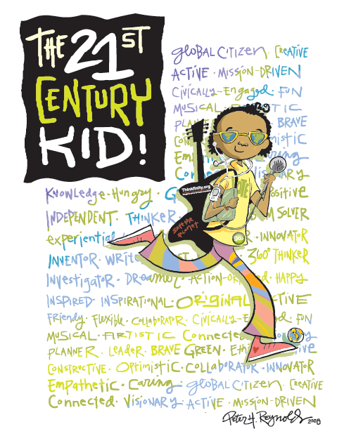
Driving much of this focus is the movement of states to adopt the Common Core State Standards (CCSS), and the use of Webb’s Depth of Knowledge to assess implementation of the CCSS. The Common Core Learning Standards expect students to know more cognitively demanding tasks.
Depth of Knowledge level one questions draw out student’s recall and reproduction capabilities. Depth of knowledge level two questions focus on basic applications of skills and concepts and basic reasoning. Depth of knowledge level three questions focus on strategic thinking and complex reasoning. Discussions of Webb’s levels can be quite detailed, but for our purposes here, the focus will be on the level four questions, which requires extended thinking.
The Hess Cognitive Rigor Matrix has been used to help educators bridge the chasm between the Bloom’s Taxonomy, which they are very familiar with, and the Webb’s Depth of Knowledge scale, which is somewhat new still.
Converting learning to a visual format. As we progress through this chapter, you will learn ways that you can use the Hess Cognitive rigor matrix to address both Bloom’s Taxonomy and CCSS, with a particular focus on the level 4 depth of knowledge scale.
Remembering
This element of Bloom’s taxonomy does infer the retrieval of material. This is a key element given the growth in knowledge and information. Webb’s levels of knowledge use basic recall as a starting point in it’s hierarchy of knowledge complexity.
Visual additions and their explanations are as follows:
Bullet pointing – This is analogous to listing but in a digital format. It is the visual ordering of information, typically used in creation of powerpoints. Referencing Guy Kawaski’s 10 – 20 – 30 rule is helpful here: No more than ten slides, no longer than 20 minutes, and no fonts smaller than 30 point.
http://blog.guykawasaki.com/2005/12/the_102030_rule.html
Brain-based research conducted by the 3M Corporation in “The Power of Color in Presentations:” We process images 60,000 times faster than text. Students score 35% better with illustrated texts. Color visuals increased willingness to read, motivation, and participation by up to 80%. Color enhanced learning and improved retention by more than 75%. Color accounts for 60% of the acceptance or rejection of an object.
Highlighting – This is a key element of most productivity suites; encouraging students to pick out and highlight key words and phrases is a technique for recall. Colors can be very important in denoting the emotional connection to the topic, as well as improving student recall of the topic.
Color Language
1. 80% of a person’s impression on a product is based upon its color
2. Color call to mind specific emotional responses
3. Solemn events are depicted in black and white
4. Adding a highlight color increases comprehension and recall
5. Light blue, yellow, yellow-green, and orange seem to help the learning environment
6. Warm colors are active and exciting
7. Cool colors are passive and calming
Color Meanings
Red Danger, Heat; Yellow Warmth; Green Life, youth; Blue Cool; Brown Age, Earth, Soil - Paler Colors Distance
http://www.sspweb.com/SSP/visual_lit/VisualLitOnline.pdf

A simple recall activity that can begin to move up the Depth of Knowledge chart is Student Created Word Game Quiz.
Think of fifteen words that are essential to the understanding of the book or chapter. Explain why you picked the words you did and how you would define them in terms of the story or chapter. Share the words in classtools.net, creating definitions that fit the context of how the words were used in the chapter being reviewed. Play a game or puzzle based off of your list. A Elements example can be seen here:
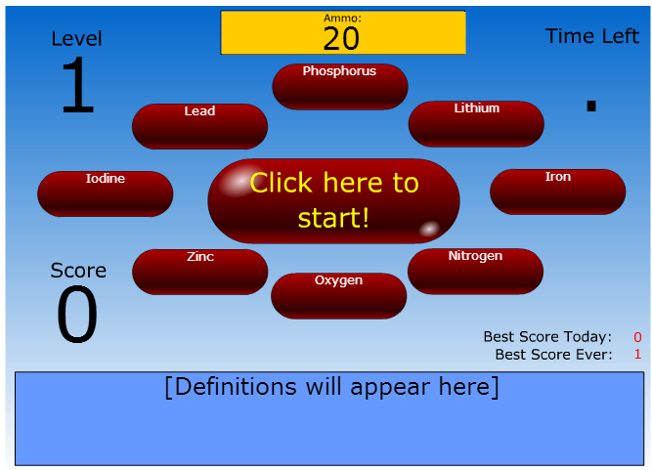
This particular game is a variation of a old arcade game and is called WordShoot. The game does not have to be better than World of Warcraft, it just has to be better than copying words and definitions from the glossary. Once you start playing, you are on the clock! This game gets increasingly complex as you move up levels. However, for games, that is a good thing. The worst thing said about homework – “it’s too hard”. The worst thing said about a game – “it’s too easy”.
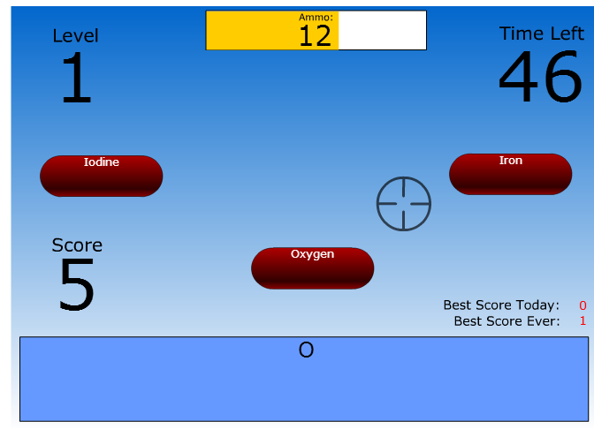
http://www.classtools.net/widgets/quiz_5/oANRy.htm
There are many simple matching games on the internet that are highly visual and somewhat interactive.
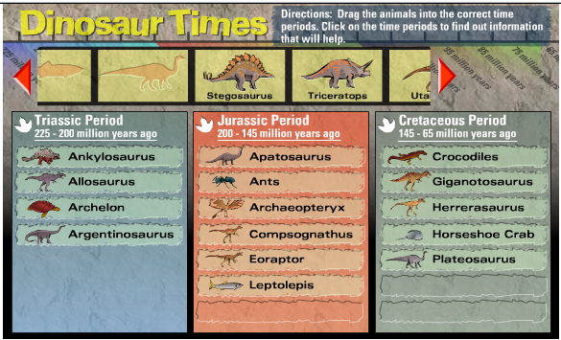
Here is a “drag and drop” example from Scholastic.
http://www.scholastic.com/kids/dinotimes/flash.htm

Key Terms - Remembering:
Using colors, organizing points visually and playing visual games can be a excellent way to help students recall key concepts.

Understanding

Webb's Depth of Knowledge chart relates to Understanding at four different, increasingly complex levels.

Level 1: recall and reproduction, asks students to identify and describe literary elements, such as characters, setting or sequence; Select appropriate words when the intended meaning or definition is evident; describe or explain who, what, when where or how; define or describe facts, details, terms or principles

Level 2: Specify, explain why, show cause and effect; give examples and nonexamples (identifying similarities and differences (Marzano)); summarize results, concepts or key ideas; make basic inferences or logical predictions from data, or texts; locate information to support explicit-implicit central ideas.

Level 3: Explain, generalize or connect ideas using supporting evidence; identify or make inferences about explicit or imnplicit themes; Describe how word choice, point of view or bias may affect readers interpretation of the text; Write a multi-paragraph composition for specific purpose, focus, voice, tone and audience. [Authors note: while working as a reading and writing specialist at a inner city school in Cincinnati, I found using photographs with sticky notes MUCH more effective at helping students to express themselves than writing alone. see: http://youtu.be/YL1ozU2ldzU

Level 4: explain how concepts or ideas specifically relate to other domains or concepts; draw generalizations of the results obtained or strategies used and apply them to new problem situations
Commenting and annotating – a variety of tools exist that allow the user to comment and annotate on web pages, .pdf files and other documents in writing, video and sequential art formats. The student is demonstrating understanding by commenting on the pages in a meaningful way. This is analogous with writing notes on hand outs, but is potentially more powerful as you can link and index these.
Talk with the Author
“Write” a video to the author of the book or chapter explaining to the author why you think he or she wrote the book and what he or she was trying to show through the book (or chapter). Cite the sections of text on which you are basing your opinion. This can be done on a iPad in a app like Educreations, or with PC tools like Photostory 3, iMovie or Windows Movie Maker. Be sure to explain what you got out of the book, using images to illustrate your favorite, most memorable or least liked points. If the author is still alive, send the video to the author via the publisher of the book or the author’s website. If not, find a blog that discusses the book, and post your comment video there. You can even post your review to the Amazon book website, but be sure to be very fair to the author if you do so. Even one bad review can really hurt their sales.
NOTE: This activity should not be limited to fiction.
- Blog Journaling – This is the simplest of the uses for a blog, where a student simply "talks" "writes" or "types" a daily- or task-specific journal. This shows a basic understanding of the activity reported upon. The blog can be used to develop higher level thinking when used for discussion and collaboration. In this case, the school can use a Fakebook page.
Fakebook is a school friendly alternative to a actual facebook page, easily created for free using the classtools.net fakebook link. Facebook can be used, but may involve issues schools do not want to deal with.
http://www.classtools.net/FB/home-page
Create a FakeBook page. Select several characters and design a home page for each of them, picking out appropriate backgrounds and pictures and then creating information in cartoon, picture, video or text that would tell a viewer about your character. Cite the sections of the text or video that lead you to your choices. Also, create links to at least five different sites that you think your character would be interested in. Then write up and post on the page an explanation of how you made the decisions you did and what you believe this tells us about the character using references from available text, pictures and video to support your choices.

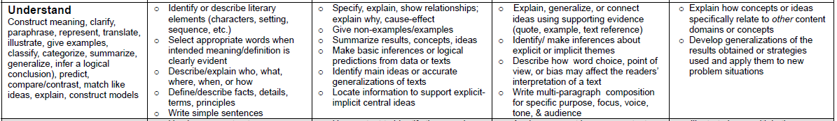
Key Terms - Understanding:
Interpreting, Summarizing, inferring, paraphrasing, classifying, comparing, explaining, exemplifying, blog journaling, categorizing and tagging, commenting, annotating, subscribing.

Applying

Apply - Carry out a procedure in a given situation;

Webb's Depth of Knowledge Level one: use language structure, including prefixes and suffixes or word relationships such as antonyms and synonyms to determine the meaning of words; Apply rules or resources to edit spelling, grammar, punctuation conventions and word use; Apply basic formats (APA, MLA) for documenting sources

Level 2: Use context to help identify the meaning of words or phrases; obtain and interpret information using text features; develop a text that may be limited to one paragraph; apply simple organizational structures (paragraph, sentence types) in writing.

- Cartoon Squares
- Create a series of six drawings or squares in Pixton or MakeBeliefscomix that shows a significant event in the novel, or an actual historic or scientific event. Under each picture or cartoon, write a few lines of explanation. If using Make Beliefs Comix, print to pdf to share.

Level 3: Apply a concept in a new context; revise a final draft for meaning or progression of ideas; apply internal consistency of text organization and structure to composing a full composition; apply word choice, point of view, style to impact readers' or viewers' interpretation of the text

Level 4: illustrate how multiple themes (historic, geographic, social) may be interrelated; select or devise a approach among many alternatives to research a novel problem.

- Character Astrology Signs
- After reading brief descriptions of the astrology or sun signs, figure out which signs you think three of the main characters from your book or scientists or mathematicians were born under. Write an explanation of why you think they fit the sign, drawing on their actions, attitudes, and thoughts from the book. Create a place mark in Google Sky (Google Earth) with an explanation of how that sign describes your person or character. Save as a kml file for sharing. You will likely want to use a skychart app off of your iPad to help locate the constellations.
- Heroes and Superheroes
- Select two or three people your character/Scientist/Mathematician would think of as a hero or superhero. Describe the characteristics of the hero and why those characteristics would be important to your character. Also describe which characteristics your character would most want for himself/herself that the hero or superhero possesses. Create your character at the Marvel Comics SuperHero Gallery. http://marvel.com/games/cyos

The visual digital additions and their justifications are as follows:
Playing – The increasing emergence of games as a mode of education leads to the inclusion of this term in the list. Students who successfully play or operate a game are showing understanding of process and task and application of skills.
Uploading and Sharing - uploading materials to websites and the sharing of materials via sites like flickr etc. This is a simple form of collaboration, a higher order thinking skill.
Editing – With most media, editing is a process or a procedure that the editor employs.
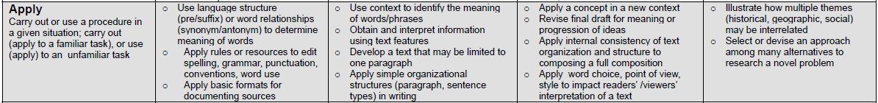
Key Terms - Applying:
Implementing, carrying out, using, executing, running, loading, playing, operating, hacking, uploading, sharing, editing.

Analyzing

Analyze - Break into constituent parts, determine how parts relate, differentiate between relevant and irrelevant, distinguish, focus select, organize, outline, find coherence, deconstruct (for possible bias or point of view)

Level 1:Identify whether specific information is contained in graphic representations or text features; decide which text structure is appropriate to audience and purpose.

Level 2:categorize/compare literary elements, terms, facts/details, events; identify use of literary devices; analyze format, organization & internal text structure (signal words, transitions, semantic cues) of different texts; distinguish between relevant and irrelevant information, or between fact and opinion; identify characteristic text features, distinguish between texts, genres.

- Google Map Maker
- Become a Map-Maker. After selecting and reading a book or story or exploration that involves a journey of some sort, students create a detailed map in Google Maps using placemarks. The placemarks can be edited to include descriptions, and even movie links illustrating the significant places (e.g. Taj Mahal) and important geographic locations (India) in the book. The map can be made public and shared. An example may be found on the journey of Anne Frank:
http://www.googlelittrips.com/GoogleLit/Home.html

Level 3: Analyze information within data sets or texts; analyze interrelationships among concepts, issues and problems; analyze or interpret author's craft (literary devices, viewpoint or potential bias) to create or critique a text; use reasoning, planning and evidence to support inferences

One way students could learn to interpret a authors bias would be to explore, or create, their childhood.
Create a Childhood
Using educreations app on the iPad, draw a series of slides that show what your character, author, scientist or mathematician as he or she would have been as a child. Save the slides as images, and upload. Write the story of his or her childhood in such a way that shows why he or she is the way he or she is in the novel, or in their biographical information.

Level 4: analyze multiple sources of evidence or multiple works by the same author or across genres, time periods or themes; analyze complex or abstract themes, perspectives and concepts; gather, analyze and organize multiple information sources; analyze discourse styles

The digital additions and their explanations are as follows:
- Mashing – mash ups are the integration of several data sources into a single resource. Mashing data currently is a complex process but as more options and sites evolve this will become an increasingly easy and accessible means of analysis.
- Linking – this is establishing and building links within and outside of documents and web pages.
- Reverse-engineering – this is analogous with deconstruction. It is also related to cracking often with out the negative implications associated with this.
- Cracking – cracking requires the cracker to understand and operate the application or system being cracked, analyse its strengths and weaknesses and then exploit these.
- Validating – With the wealth of information available to students combined with the lack of authentication of data, students of today and tomorrow must be able to validate the veracity of their information sources. To do this they must be able to analyse the data sources and make judgements based on these.
- Tagging – This is organising, structuring and attributing online data, meta-tagging web pages etc. Students need to be able understand and analyse the content of the pages to be able to tag it.
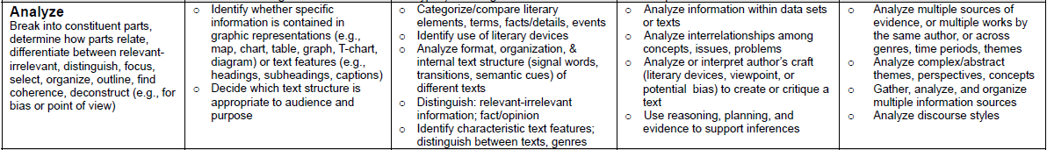
Key Terms - Analyzing:
Comparing, organizing, deconstructing, Attributing, outlining, finding, structuring, integrating, Mashing, linking, reverse-engineering, cracking, mind-mapping, validating, tagging.

Evaluating

Evaluate - Make judgements based on criteria, check, detect inconsistencies or fallacies, judge, critique
(no level 1 or 2 applies to evaluate)

Level 3: Cite evidence and develop a logical argument for conjectures; describe, compare and contrast solution methods; verify reasonableness of results; justify or critique conclusions drawn.

- Critique from the point of view of a specific organization
Select an organization that might have a lot to say about the actions or portrayals of characters in the novel you read, and write a critique of the book from its point of view. For example the Society for the Prevention of Cruelty to Animals might have a lot to say about Lennie’s treatment of animals in Of Mice and Men, or the National Organization of Women on the portrayal of Curley’s wife and the fact that she was never given a name.
Use Filamentality to create a webquest with a variety of roles that include that point of view.

Level 4: Evaluate relevancy and accuracy and completeness of information from multiple sources; Apply understanding in a novel way, provide argument or justification for the application

- Dream Vacation
Where do you think your character, explorer or scientist would most like to go on a vacation? Pick a spot in Google Maps, describe it, and explain why they would want to go there. Add a placemark and save the map. Download information from the Internet on the place. Then create a photostory or animoto showing a day-by-day itinerary of what the character would do each day. Add descriptions or links to movies in the placemark. If creating a movie, explain why the character or person would like these activities.

The visual digital additions and their explanations are as follows:
- Blog/vlog commenting and reflecting – Constructive criticism and reflective practice are often facilitated by the use of blogs and video blogs. Students commenting and replying to postings have to evaluate the material in context and reply.
- Posting – posting comments to blogs, discussion boards, threaded discussions. These are increasingly common elements of students' daily practice. Good postings like good comments, are not simple one-line answers but rather are structured and constructed to evaluate the topic or concept.
- Moderating – This is high level evaluation; the moderator must be able to evaluate a posting or comment from a variety of perspectives, assessing its worth, value and appropriateness.
- Collaborating and networking – Collaboration is an increasing feature of education. In a world increasingly focused on communication, collaboration leading to collective intelligence is a key aspect. Effective collaboration involves evaluating the strengths and abilities of the participants and evaluating the contribution they make. Networking is a feature of collaboration, contacting and communicating with relevant person via a network of associates.
- Testing (Alpha and Beta) – Testing of applications, processes and procedures is a key element in the development of any tool. To be an effective tester you must have the ability to analyze the purpose of the tool or process, what its correct function should be and what its current function is.

Key Terms – Evaluating:
Checking, hypothesising, critiquing, experimenting, judging, testing, detecting, monitoring, (Blog/vlog) commenting, reviewing, posting, moderating, collaborating, networking, reflecting, (Alpha & beta) testing.

Creating

Create - reorganize elements into new patterns or structures, generate, hypothesize, design, plan , produce

Level 1: Brainstorm ideas, concepts, problems or perspectives related to a topic or concept

Wordle Word Collage
Write the title of the book in the Wordle text entry three times, to assure it’s prominence. Then look for words, phrases, and sentences that illustrate or tell something about your book, scientific discovery or historical fact. As you look, think in terms of the theme, setting, plot line (if any), as well as characters. Work to get fifty such words, phrases, or sentences so the whole Wordle is well represented. The visual impact of the Wordle should tell a potential reader a lot about the significant ideas.

Level 2: generate conjectures or hypotheses based on observations or prior knowledge and experience

Movie Recommendations
From all the movies you’ve seen in the last couple of years, pick five you would recommend that your character or author or scientist to see. Give a brief summary of each movie and explain why you think the character should see it. Share your recommendation and reasons on IMDB.

Level 3: Synthesize information within one source or text; develop a complex model for a given situation; develop a alternative solution

- Music
After reading a novel or chapter, figure out how you would divide up the reading into sections. Then select a piece of music from YouTube that you think captures the feel or tone of each section. Download the music using AnyVideoConvertor. If possible do voice-overs (Garage Band on the Mac works for this) explaining what is happening in the reading during the piece of music and why you felt this piece of music fit the section of the novel or reading.
- poetry
Write three poems in response to a story or reading. The poems can be about the characters, where the book took place (setting), or the themes in the book. For younger students struggling to get started, this Shape Poem format may be a good starting point. Thinkfinity can help your students generate many other types of poems as well. Be sure to refine your search using the “Interactives” checkbox.

Level 4: synthesize information across multiple sources or texts; articulate a new voice, alternate theme, new knowledge or perspective

- Celtix Story Script
Student partner to write a movie script using Celtixfor a favorite scene in a book or chapter just read. At the top of the script, the student can assign real-life TV or movie stars to play each role. The student can also work with classmates to perform the favorite scene. The script can be uploaded into xtranormal, or acted out and uploaded into YouTube or created as a Reader’s Theater script.

The digital additions and their explanations are as follows:
- Programming – Whether it is creating their own applications, programming macros or developing games or multimedia applications within structured environments, students are routinely creating their own programs to suit their needs and goals.
- Filming, animating, videocasting, podcasting, mixing and remixing – these relate to the increasing availability of multimedia and multimedia editing tools. Students frequently capture, create, mix and remix content to produce unique products.
- Directing and producing – to directing or producing a product, performance or production is a highly creative process. It requires the student to have vision, understand the components and meld these into a coherent product.
- Publishing – whether via the web or from home computers, publishing in text, media or digital formats is increasing. Again this requires a huge overview of not only the content being published, but the process and product. Related to this concept are also Video blogging – the production of video blogs, blogging and also wiki-ing - creating, adding to and modify content in wikis. Creating or building Mash ups would also fit here.
Key Terms – Creating:
designing, constructing, planning, producing, inventing, devising, making, programming, filming, animating, Blogging, Video blogging, mixing, remixing, wiki-ing, publishing, videocasting, podcasting, directing/producing, creating or building mash ups.
Bibliography
- See more at: http://www.techlearning.com/studies-in-ed-tech/0020/blooms-taxonomy-blooms-digitally/44988#sthash.RZyZ0o24.dpuf
You can develop an alternative VISUAL assessments in any subject area. Help students extend the product of their learning beyond the classroom to a wider audience, and let parents KNOW you are teaching students 21st century skills by giving students 21st century skills artifacts of learning to PROVE their mastery.

- Title Acrostic
Go to Thinkfinity and write the title of the book or key event or element as an acrostic poem. For each letter in the title, construct a sentence that begins with that letter and that tells something significant about the story or event or element.
http://www.readwritethink.org/files/resources/interactives/acrostic/
- Scrap Blog
Think about all the kinds of mementos you would put in a scrap blog if you had one. Then create a scrap blog for your character, scientist, mathematician or explorer, downloading pictures from the Internet or drawing for them in MSPaint the mementos he or she would have in a scrap blog. Create and share the poster in Glogster.
- Photos
In Flickr or PhotoBucket, find two or three photos that would have special significance to your character, scientist or explorer. Add the photos to Photostory 3 or iMovie to make a movie about why those pictures would be important to your character. Share your movie and rate each others movies according to a rubric the class agrees on.
- Tangible or Intangible Gifts
Select a character, scientist or explorer and figure out what two or three things you believe your character most needs or wants. Draw or download pictures to represent these “gifts” and write to your character an explanation of why you picked these things out for him or her. Share your writing by uploading and sharing your file in Google drive.
- Point of view
Have students partner. Write an opinion column like those that appear on the editorial page of the newspaper. Choose a theme or topic from the novel you just read and write the column from the point of view of one of the characters. Your character might write about the importance of education or why we should accept people who are not like us.
Post to an appropriate Blog, or create your own just for this topic. Or create a free WIX website with a comments page for sharing.
- Book Choices
Book choices for character or author. Select a character (or author) and then choose five books for him or her, thinking about what he or she might like and also what you think they need to know more about. Use Amazon.com to select your books. Why did you select the nonfiction books you did? What do you hope your character will like about or get out of the writings?
- Create a bedroom
What would a teenaged Einstien’s bedroom look like? We learn a lot about people by what they keep in their closets, what they have on their walls, what they select to put in a room. Select a character or author or scientist you know well and create a living room, bedroom, kitchen, or cabin that would mean a lot to the character. Draw it in Sketchup or create it in SecondLife, making sure to include an explanation of why you designed the room as you did.
- Credits
- Rubistar.4teachers.org
You may not know how to grade what you are doing until after you have done it. On the “first run”, use a very low point value. Then have students evaluate as a class. What makes a project great, or horrible, then work to the center.
- Schooltube.com for sharing video.
- Cutepdf printer, for printing pdfs instead of killing trees.

- Fifty Alternatives to the Book Report by Diana Mitchell
English Journal, Jan 98 p 92-95
- Challenging, Meaningful, and Even Enjoyable Alternatives to Traditional Book Reports by William P. Bintz, Kent State University,
Sara D. Moore, ETA/Cuisenaire,
2010 IRA World Congress

